Position / Job Title: Duty Supervisor (Chapel Gate) (Part Time, x2 Positions Available)

Ref: 171

Location/Building: BU Sports Campus, Chapel Gate

Faculty/Professional Service: Student Services

Group/Section: Sport and Culture

Duration if temporary: N/A

Normal hours per week: 30
(Some flexibility will be required in order to ensure that key time scales and deadlines are met).

Grade: 3

Accountable to: Duty Manager (Chapel Gate)

Responsible for or supervises: Part time Sports Assistants x5

We are committed to providing a safe environment for all students and staff. This position is required to undertake regulated activity and therefore is exempt from the Rehabilitation of Offenders Act (ROA) 1974 and subject to a satisfactory (enhanced) DBS Disclosure and the requirements of our Safeguarding Policy.

Job Purpose

BU purchased the 65-acre Chapel Gate site in July 2019, and has since made and committed to significant improvements and development of the site. We are now looking to expand the operational staff team for enhanced customer service and operational needs.
The Duty Supervisor will work on a regular shift basis over seven days ensuring the effective delivery of services at Chapel Gate. The post holder will ensure the efficient running of the facility and will support the Operations Manager across all of areas. This will include operational tasks, health & safety and social media.
We must ensure we are fulfilling our requirements to the various tenants, leaseholders and sections on site to ensure Chapel Gate remains a quality hub of community sport in the BCP conurbation.

Main Responsibilities

- Take sole responsibility for all sports facilities and associated areas whilst on shift and ensuring they are safe and ready to use at all times. To ensure the sports facilities operate safely in line with H&S requirements whilst maintaining operational efficiency. At Chapel Gate, over the 65-acre site, this will include the reception area, bar and catering areas, sports fields, artificial pitches, changing rooms and team office.
- Assist the General Manager to lead and lead in the coordination and delivery of activities including developing and growing programmes to enhance student experience and attraction.
- Effective line management of relevant PTHP sports assistant staff adhering at all times to relevant BU policies and procedures. Foster and actively promote a ‘can do’ culture which consists of a customer focussed delivery of services and a positive team spirit. Supervise work output and performance on a regular basis.

- Ensure all facilities areas and equipment are properly prepared (and reinstated) prior to customer use in accordance with programmed activities and to control access to the facilities as required.

- To undertake regular building and facility checks for cleanliness, health and safety and maintenance defects whilst ensuring all visitors adhere to rules, regulations and conditions of hire. To report and escalate all maintenance defects to ensure standards are maintained and escalate any concerns to the Duty Manager or General Manager.

- To continually assess, evaluate and monitor all health & safety considerations of facilities, centre staff and customers whilst on shift and deal with emergencies following BU guidelines as appropriate. Assist Duty Manager with daily checks of machinery, risk assessments and follow BU procedures for contractors coming to site.
- Act as a fist aider whilst on shift providing cover for the Chapel Gate site.
- Be responsible for all the first aid consumables for Chapel Gate. Liaise with Estates team and restock when required.
- Manage and plan all staff rotas. This includes using Teams to effectively share information and create processes to ensure AL is recorded within the rotas.
- Working with the Duty Manager, ensure the departmental operation manual and procedures are continually updated and shared with staff as appropriate.
- As an Operations team and working with the Grounds team, provide support for on the day match preparations. This will include pitch and changing room allocations, cancellations, car parking management and a point of contact for all on the day enquiries.
- Act as a point of contact for community bookings, tenants and sections to ensure their relevant sporting and facility needs are met.
- To assist in business generation ideas to utilise Chapel Gate facilities during quiet times, starting with conception, through development with relevant stakeholders, to delivery and ongoing management responsibility.

- Ensure the delivery of excellent customer service and a positive user experience. Proactively take responsibility for the customer journey providing resolutions where required.

- Ensure an excellent working knowledge of the sites booking system and point of sale. Be able to assist customers efficiently in resolving their issues.
- To ensure proper accounting and reconciliation of daily cash receipts when on duty in accordance with BU Financial Regulations.
- Assist the Duty Manager in the daily operations of Chapel Gate e.g. reception and cleaning duties, as required ensuring the smooth running of the department.
- Proactive engagement in all areas of Chapel Gate/SportBU business activity. Be creative and driven to investigate, influence and establish possible new areas of business activity that relate to the strategic direction of the department.
- Participate in SS and University wide events (e.g. open days, fresher’s activities) where appropriate.
- To actively contribute to the delivery of the SS Plan within the remit of your job, with the ultimate aim of enhancing student experience and providing a high-quality service to all customers, whilst improving efficiency and effectiveness of core University processes and systems.
- To undertake any other appropriate duties as required.

Organisation Chart

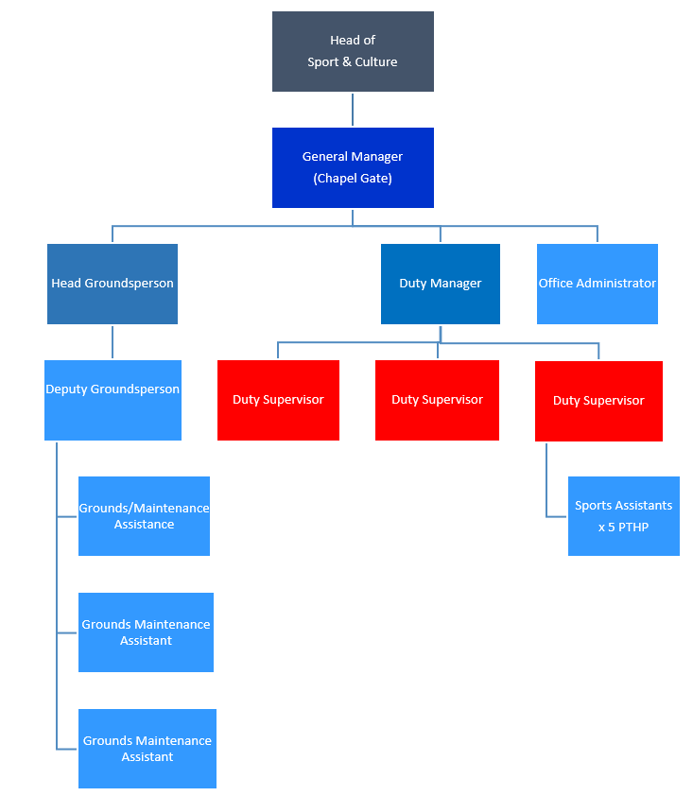

Contacts

Internal: SportBU colleagues, SS colleagues, students, staff, Estates, IT, SUBU, Finance, Marketing and Communications

External: Community clubs, schools, Chapel Gate Tenants, Lul Med services, external partners, Other HE institutions

Information Governance Responsibilities

Data User
Comply with the associated data protection, information security, information management and information technology regulations, policies, processes and procedures.

Safeguarding and Regulated Activity

If the role involves engaging in regulated activity relevant to vulnerable groups including children and disabled adults, it is an offence to apply for and perform the role, if a person is bared from engaging in regulated activity. Further information is available in BU’s Safeguarding Policy and Suitability Statement on the Recruitment and Employment of Ex-offenders.
Additional Information

NB:
The purpose of the job description is to indicate the general level of responsibility and location of the position. The duties may vary from time to time without changing their general character or level of responsibility.

BU is an equal opportunities employer which values a diverse workforce. The post holder must at all times carry out their responsibilities with due regard to the University’s Dignity, Diversity and Equality Policy Statement.

Our highly skilled and creative workforce is comprised of individuals drawn from a broad cross section of the globe, and who reflect a variety of backgrounds, talents, perspectives and experiences to build our global learning community. Through fused activity, the post holder must have an understanding of and commitment to promoting a global outlook.

All employees have an obligation to be aware of and comply with the Universities Sustainability Policy, Climate and Ecological Crisis Action Plan and associated documents, and to ensure that whilst at work that they demonstrate the adoption of sustainable habits or practices and carry out their day-today activities in an environmentally responsible manner.

September 2024

 | Person Specification
Post / Job Title: Duty Supervisor (Chapel Gate) (Part Time, x2 Positions Available)
Post No: 171
School / Service SportBU (Student Services) Date: September 2024
SELECTION CRITERIA |  | Essential / Desirable
Knowledge (including experience & qualifications)
Experience of working within a multi-facility leisure environment |  | E
Knowledge of health and safety guidelines appropriate to the sport and leisure facility environment |  | E
Experience of and ability to liaise with University staff and students, general public, related organisations and industry |  | E
Experience of working in customer facing roles |  | E
Experience of organising activities and online content |  | D
Experience of cash reconciliation and financial management |  | D
Experience of working with a leisure management booking system |  | D
Supervisory/management qualification or equivalent experience |  | D
Experience of organising and delivering sports programmes or events, working with multiple stakeholders. |  | D
Experience of artificial or natural turf maintenance practices |  | D
Skills
Excellent interpersonal communication skills |  | E
Highly organised with the ability to simultaneously engage with multiple tasks. |  | E
Strong time management skills |  | E
Accurate word processing and data entry skills |  | E
Proven general administration skills |  | E
Competent IT and Social Media skills |  | E
Attributes
A positive can-do attitude and excellent team player |  | E
Ability to motivate and delegate where appropriate |  | E
Proven ability to work on own initiative |  | E
Good attention to detail |  | E
Assertive but with reservation, diplomacy and tact when appropriate. |  | E
Pro-active in engaging with all elements of the business, keen to learn and grow within the department |  | E
Flexibility approach to the working day/week to work on a shift rota basis to include regular evening and weekend working |  | E
Customer focussed |  | E

