**Position/Job Title Duty Manager (Marketing and Communications)**

**Ref: 222/** **POSN105063**

**Location building: SportBU**

**Faculty/Professional Service: Student Services**

**Group/Section: Sport & Culture, SportBU**

**Normal hours per week: 37**

**(Some flexibility will be required in order to ensure that key time scales and deadlines are met)**

**Grade: G4**

**Accountable to: Operations Manager**

**Responsible for or supervises: Duty (Supervisor M&C), Media Volunteers**

**Special Conditions:** **Subject to satisfactory DBS Disclosure**

**Job Purpose**

The post holder will be responsible for managing the development and operational management of SportBU’s marketing and communications. This will comprise of social media, marketing campaigns, marketing materials and large event support. The role will be responsible for assisting the design of vibrant programmes and marketing materials that attracts the target market through creative implementation of up-to-date sports programmes.

The postholder will be an integral part of the Operations team, ensuring a safe, compliant sporting environment is available to our customer base to the highest possible standards. The postholder will work on a regular shift basis ensuring the efficient and effective delivery of services within SportBU.

**Main Responsibilities - Operations**

1. To act as a Duty Manager on a shift rota basis to include regular evening and weekend working. This involves being solely responsible for all sports facilities and associated areas whilst on shift and ensuring they are safe and ready to use at all times. Be the first port of contact for staff and coaches/instructors who come onto site. Lead the operational PTHP staff to ensure high standards are adhered to.
2. Ensure all facilities areas and equipment are properly prepared (and reinstated) prior to customer use in accordance with programmed activities and to control access to the facilities as required.
3. To undertake regular building and facility checks for cleanliness, health and safety and maintenance defects whilst ensuring visitors adhere to rules, regulations and conditions of hire. To report and liaise with relevant parties all maintenance defects to ensure standards are maintained and escalate any concerns to the Operations Manager.
4. To continually assess, evaluate and monitor all health & safety considerations of facilities, centre staff and customers whilst on shift and deal with emergencies following BU guidelines as appropriate.
5. Deliver excellent customer service on a day-to-day basis to ensure a positive user experience. Be the first point of call in dealing with complaints and be proactive in solutions for any customer queries to ensure they are dealt with swiftly and efficiently.
6. Ensure an excellent working knowledge of the centres XN Leisure Hub membership system. This includes the front and back end of the system. Escalate queries and anomalies to the external system provider in a timely manner to ensure swift resolution to issues. Be able to assist customers efficiently in resolving their issues to ensure it is user friendly.
7. To ensure proper accounting and reconciliation of daily cash receipts when on duty in accordance with BU Financial Regulations.
8. Assist in the daily operations of SportBU as required ensuring the smooth running of the department.

**Main Responsibilities – Marketing & Communications**

1. Operational management and accountability for generating SportBU marketing assets in line with BU guidelines. Ensure content is available in a timely manner to ensure all our media channels are up to date, informative and engaging. This will include social media, website and signage elements including communication campaigns that require working with the wider BU marketing team.
2. Line management of Duty Supervisor (Marketing & Comms) including induction, training, performance management and performance review and ensure work programmes are aligned to the strategic direction of SportBU/BU.
3. Effective recruitment and management of media volunteers, always adhering to relevant BU policies and procedures. To inspire and motivate them during the academic year by actively engaging them in the BU values and SportBU’s strategic direction. Manage the relationship between faculties to source the volunteers as well as their output.
4. Develop, manage and maintain a close working relationship with the Marketing & Communication team including Internal Comms, Digital team, Social Media team and Corporate Communications team where appropriate.
5. To manage the planning and production of marketing campaigns and materials, including writing briefs and working with relevant M&C colleagues, to support our annual programme of events in a normal academic year e.g. Freshers Fair, Refreshers, January, Varsity Day, Sports Ball etc..
6. Manage the functionality of the SportBU online forms across multiple formats (XN, Geko, Eventbrite) within the department in order to derive efficiencies and improve customer experience. Liaise with IT to ensure high levels of service delivery and exploring further advancement of the systems and forms.
7. Manage main social media channels for SportBU including content and programming. Train other SportBU staff to manage their own channels and advise accordingly. Create a monthly plan on content and execute delivery.
8. Continually manage the main SportBU website to ensure it remains accurate and relevant within the current market. Gain approval from M&C where required in a timely manner before publishing.
9. Develop and manage internal processes to collect content and stories/appropriate material that can be used in PR and promoting SportBU/University on and offline.
10. Work with the Operations Manager on large scale IT developments in the department e.g. XN leisure management system improvements or new website changes.
11. Guide and manage staff within SportBU to ensure branding guidelines are correct to ensure we maintain the accuracy and consistency of marketing information, both on and offline.
12. Provide and practice expert knowledge of current trends in the sector including social media, IT efficiencies to ensure the SportBU remains a cutting-edge facility and satisfying changing customer needs.
13. Develop innovative ways to engage and retain the existing customer base and ways to grow develop our customer base further (e.g. community members, promotions). Design ways to gain customer feedback and measure impact and respond accordingly by making appropriate changes and/or recommendations to senior management.
14. Work with Health, Safety & Wellbeing, Res Life teams and SUBU to create a programme of University wide health and fitness events which promote SportBU and BU to the University population, encouraging them to lead a healthier lifestyle. Utilise the student body to assist in running health & fitness events where appropriate.
15. Being autonomous in actively seeking, developing and maintaining opportunities for joint working arrangements and partnerships with other BU departments, SUBU, local schools, sports clubs and NGBs across the conurbation to broaden the opportunities for students to participate in sport and physical activity. Partnerships should have the capability to generate income and/or enhance student experience.
16. To provide administrative and organisational support for SportBU-wide events.
17. Be creative and driven to investigate, influence and establish possible new areas of business activity that relate to the strategic direction of the department.
18. Participate in SS and University wide events (e.g. open days, fresher’s activities) where appropriate.
19. To actively contribute to the delivery of the SS Plan within the remit of your job, with the ultimate aim of enhancing student experience and providing a high-quality service to all SSS customers, whilst improving efficiency and effectiveness of core University processes and systems.
20. To undertake any other appropriate duties as required.

**Organisation Chart**

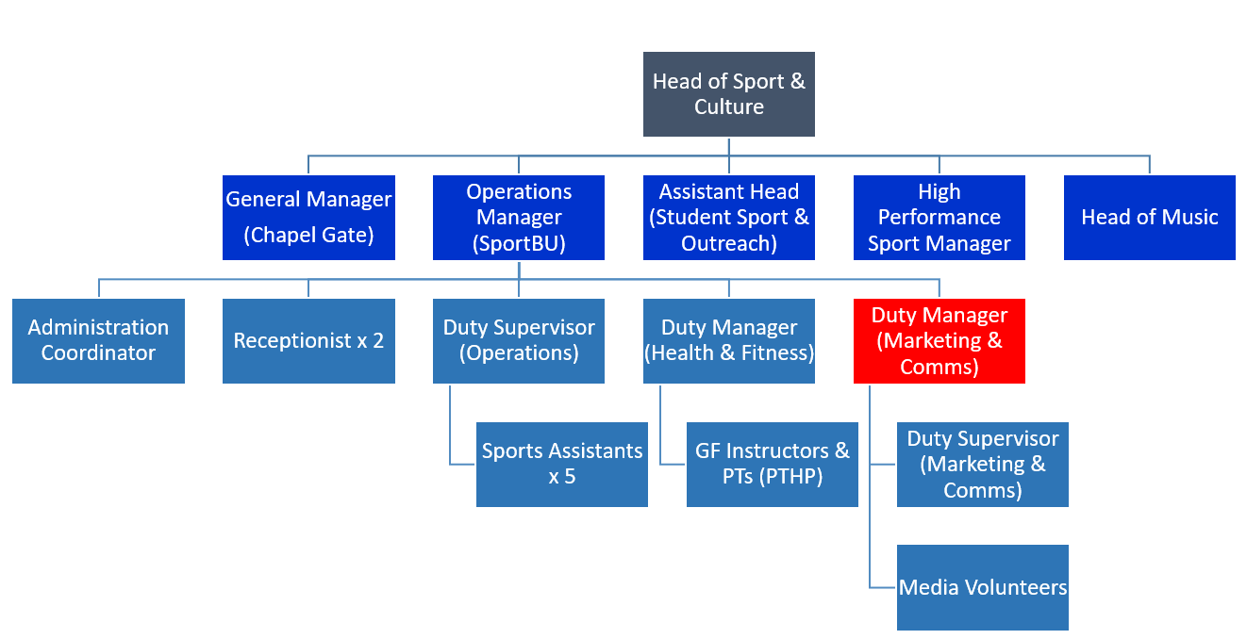

**Contacts**

**Internal:** SportBU colleagues, CS colleagues, students, Staff, other SS Directorate colleagues, Estates, IT, M&C, Finance, Cash Office, Legal Services, Students Union

**External:** Customers,Manufacturers and Suppliers, relevant personnel appropriate to industry,

**Challenges**

The main challenge of this role is balancing operational responsibilities on a regular basis with marketing and communications tasks.

SportBU need to remain proactive in the creation and dissemination of news stories and information

**Information Governance Responsibilities**

Data User

1. Comply with the associated data protection, information security, information management and information technology regulations, policies, processes and procedures.

**Safeguarding and Regulated Activity**

If the role involves engaging in regulated activity relevant to vulnerable groups including children and disabled adults, it is an offence to apply for and perform the role, if a person is bared from engaging in regulated activity. Further information is available in BU’s Safeguarding Policy and Suitability Statement on the Recruitment and Employment of Ex-offenders.

**Additional Information**

The purpose of the job description is to indicate the general level of responsibility and location of the position.

The duties may vary from time to time without changing their general character or level of responsibility.

BU is an equal opportunities employer which values a diverse workforce. The post holder must at all times

carry out their responsibilities with due regard to the University’s Dignity, Diversity and Equality Policy

Statement.

Our highly skilled and creative workforce is comprised of individuals drawn from a broad cross section of the

globe, and who reflect a variety of backgrounds, talents, perspectives and experiences to build our global

learning community. Through fused activity, the post holder must have an understanding of and commitment

to promoting a global outlook.

All employees have an obligation to be aware of the University’s Sustainability Policy, Climate and Ecological

Crisis Action Plan, Travel Plan and associated documents, and to ensure that they carry out their day-to-day

activities in an environmentally responsible manner and inspire students to do the same.

**October 2024**

|  |  |  |
| --- | --- | --- |
| Description: BU_CoreLogo_portrait_colour | **Person Specification** | |
| Position / Job Title: **Duty Manager (Marketing and Communications)**  Position No: **POSN105063**  Faculty/ Service: **SportBU (Student Services)** Date: **October 2024** | | |
|  | |  |
| **SELECTION CRITERIA** | | **E**ssential / **D**esirable |
| **Knowledge (including experience & qualifications)** | |  |
| Degree or equivalent qualification/experience in a relevant subject area | | E |
| Experience of working in a multi-facility leisure environment | | E |
| Experience of marketing & communication strategies and tactics | | E |
| Strong knowledge of health and safety legislation & guidelines appropriate to the sport and leisure facility environment | | E |
| Experience of managing a large programme of activities and a track record of successful income generation and/or engagement | | E |
| Experience of working with a Leisure Management booking system with regards to both front and back-end management | | E |
| Experience of cash reconciliation and financial management and administration including budgeting, forecasting, invoicing and procurement activities | | E |
| Experience of line managing staff and performance management | | D |
| Knowledge of HR policies and procedures | | D |
| Experience of working in a HE environment | | D |
| Supervisory/management qualification or equivalent experience | | D |
| Experience of amending websites, social media and digital content | | E |
| Experience of working in marketing and promotions | | E |
| Experiencing of engaging with customers within an interactive platform | | E |
| **Skills** | |  |
| Able to use social media in a professional capacity | | E |
| Excellent interpersonal communication skills with the ability to communicate and network with a wide range of customers & industry contacts | | E |
| Excellent time management and organisational skills – ability to juggle multiple tasks and varied workload with deadlines being met | | E |
| Ability to work on own initiative within a busy team environment | | E |
| Ability to effectively delegate | | E |
| Proven problem-solving ability | | E |
| Proven ability to manage, lead, mentor and motivate/inspire staff around you | | E |
| Excellent IT skills and knowledge of IT systems and programmes | | E |
| **Attributes** | |  |
| Flexibility approach to the working day/week to work on a shift rota basis to include regular evening and weekend working | | E |
| A positive can-do attitude and excellent team player | | E |
| Good attention to detail | | E |
| Ability to manage a large number of tasks at any given time | | E |
| Ability to work on own initiative and generate new ideas for service delivery | | E |
| Assertive but with reservation, diplomacy and tact when appropriate. | | E |
| Creative flair | | E |
| Pro-active in engaging with all elements of the business, keen to learn and grow within the department | | E |
| Customer focussed approach to service delivery | | E |
| Ability to share information accurately and timely | | E |